

COMSATS UNIVERSITY ISLAMABAD , ATTOCK CAMPUS

Computer Science Department

Bsse-6

Course Title: | Software Re Engineering
Assignment Number: | 02
Submitted To: | Ma’am Tahira Sadaf
Submitted By: | Zainab Khan
Registration Number: | FA22-BSE-032
Date Of Submission: | 27TH March,2025

Question:
- Select legacy system. Analyze the design of code and draw class diagram.
- Identify problems in code.
- List challenges which you have encountered during execution of code
- Explain the architecture of given system.
Answer:
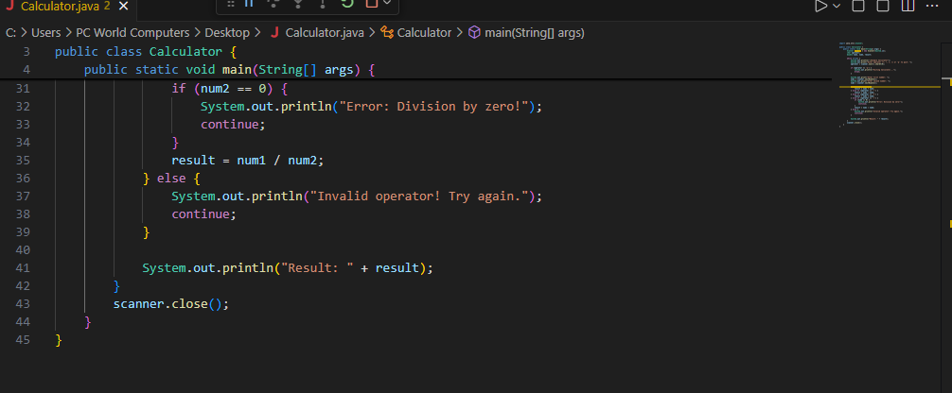
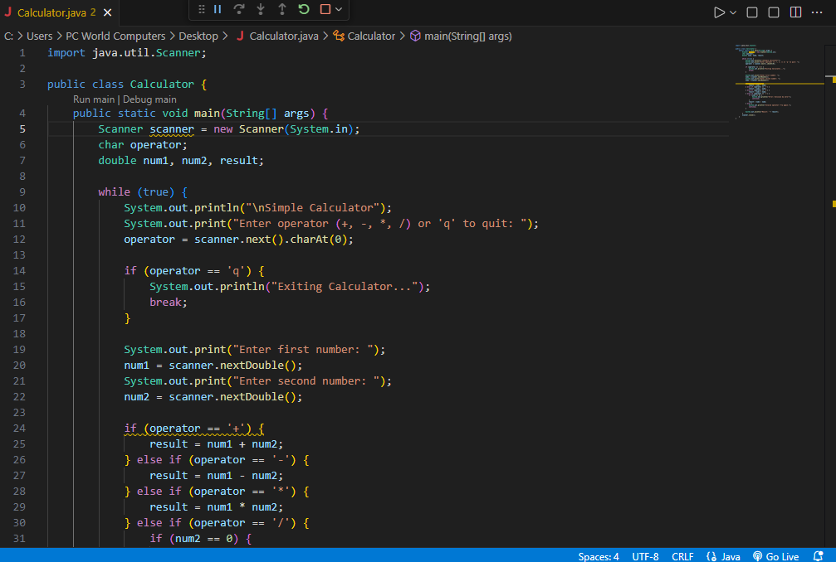
Code:

Output :
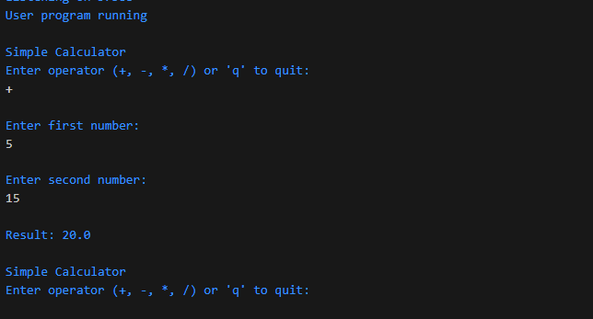
PROBLEMS IN CODE :
- The code have a monolithic structure , all the operations are performed in main class which make it little complex and difficult to understand.
- No error handling for non-numeric values in the program. When user enter non-numeric value the program throws mis match exception and discontinue. It should not discontinue but allow user to enter correct input without being discontinued.
- Operator is checked after taking both inputs, it should be verified in earlier stages, so that the chances of occurrence of errors should be reduced.
- There is no separation logics , user input ,and arithmetic operations, they should be separate to avoid coupling.
CHALLENGES IN EXECUTION:
The main challenges are :
- Non-modular design make it complex to under stand the operations of the program.
- The discontinuity of program on entering non-numeric values and trying to run it repeatedly is challenging.
- Input process and exit strategies of program make it hard to execute the program.
- Use of unnecessary conditional statements and loops make it complex to track the functionality .
Class Diagram Of Current Code :
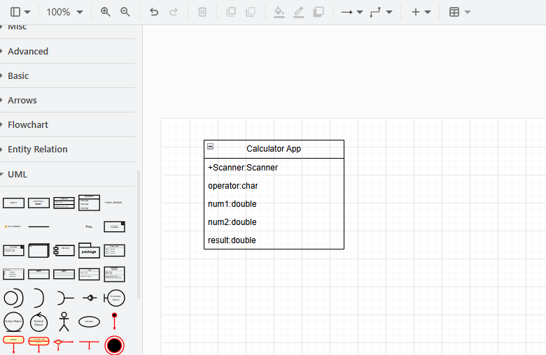
As the code follows the monolithic structure and procedural approach so all the functionality is present in main class of the program. The visual representation is given bellow,

Assumed Class Diagram Of The Code:
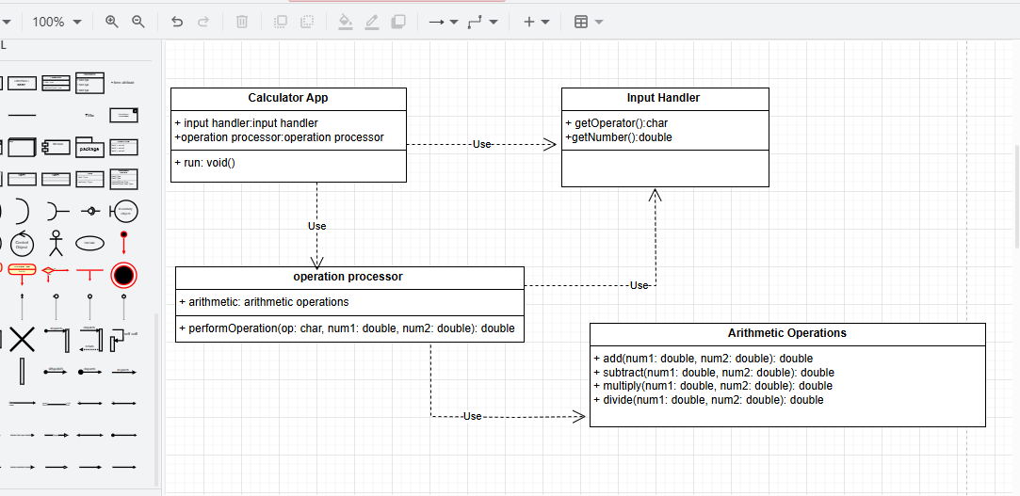
After the refactoring of the code, the code shall contain the object oriented design the code will contain separate modules (classes). So the future assumed class diagram of the code is given below,
Architecture Of The System:
The architecture of the code , is monolithic, procedural based architecture. The code follow a procedural structure and all the operations are performed in a single class. The code contains cohesive coupling. No separate classes or functionality is defined in the code.

Calculator

Operation processor
Arithmetic operations
Input handler

